Title/Author | Publisher/Copyright | Notes
Balloons over Broadway: The True Story of the Puppeteer of Macy's Parade  by Melissa Sweet  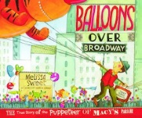 | Houghton Mifflin-2011 | Reading Level: 5.4  Interest Level: K-3  Read Aloud [7 minutes]  https://www.youtube.com/watch?v=5fRK8VUaTks
Duck for Turkey Day  by Jacqueline Jules  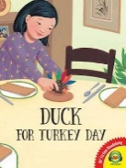 | Albert Whitman & Company - 2017 | Reading Level: 2.6  Interest Level: K-3  Read Aloud [5 minutes]  https://www.youtube.com/watch?v=sqhB4UG1M1s
The Great Turkey Race  by Steve Metzger  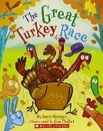 | Scholastic - 2006 | Reading Level: 2.8  Interest Level: K-3  Read Aloud [7 minutes]  https://www.youtube.com/watch?v=rRAZAmjMTxA
A Turkey for Thanksgiving  by Eve Bunting  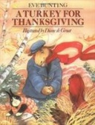 | Houghton Mifflin-1991 | Reading Level: 2.5  Interest Level: PK-2  Read Aloud [7 minutes]  https://www.youtube.com/watch?v=tEmHlir9uaU
Turkey Trouble  by Wendi Silvano  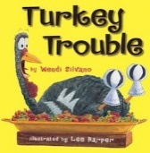 | Two Lions -2012 | Reading Level: 2.3  Interest Level: PK-2  Read Aloud [5 minutes]  https://www.youtube.com/watch?v=Fjz3--KCqkA
'Twas the Night Before Thanksgiving  by Dav Pilkey  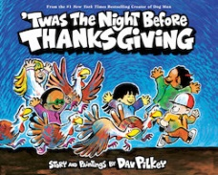 | Scholastic - 2020 | Reading Level: 4.0  Interest Level: PK-2  Read Aloud [5 minutes]  https://www.youtube.com/watch?v=oxEq-xxGvbo

