**Productive Resources**

**Introduction**: George is a curious monkey. He is also kind and helpful. Will these characteristics come in handy as he helps with a fundraiser for the children’s hospital?

**Time Required**: 20-30 minutes.

**Grade Level:** 2-4

**Materials:**

* Optional- Copy of *Curious George Makes Pancakes* by Margret & H. A. Rey
* Visual 1 - Productive Resources Poster
* Visual 2- Productive Resources Web
* Activity Sheet – Productive Resources Web
* Writing tools

**Objectives:**

* The student will explain how producers use productive resources to produce goods and services.
* The student will use a graphic organizer to communicate information.

**Procedure**:

1. Introduce the lesson by asking the students if they know how pancakes are made. After a brief discussion read *Curious George Makes Pancakes* to the class.
2. Display Visual 1- Productive Resources Poster.
3. Review the definitions using the poster as a visual aid. Note that the George is a “human” resource, the measuring cup is a capital resource, and the blueberries are natural resources.
4. Display Visual 2 - Productive Resources Web. Tell the students to pretend that George wants to learn how to cook. He now wants to learn a new skill. If he were to fill in a Productive Resources Web this is what it might look like.
5. Distribute the Productive Resources Activity Sheet and writing tools. Tell the students that they are to pretend to be entrepreneurs wishing to provide a good or a service so they can make a profit. (Possible goods and services could include a lemonade stand, yard care service, pet sitting, greeting card production, delivery services, jewelry making, and tutoring.) They are to come up with a good or service, provide a catchy product name, and fill in the web graphic with correct examples of human, capital and natural resources.
6. Encourage students to share their completed work with the class.

Visual 1-

Productive Resources Poster

* **Capital Resources** are manmade resources such tools, buildings, and vehicles used in production. The lawn mower is a capital resource.
* **Natural Resources** are gifts of nature. The bag of grass clippings that can be turned into compost is an example of a natural resource.
* **Human Resources** are people who work. Greg and Rawley wouldbe examples of human resources IF they had any skills.
* **Goods** are tangible things such as food, clothes, and cars. The boys’ boots are examples of goods.
* **Services** are physically intangible things such as medical care, haircuts, and education. Mowing lawns is an example of a service.

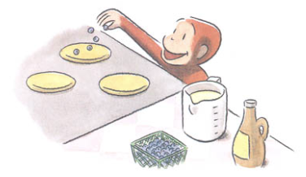

Visual 2-

**~Productive Resources Web~**

**Business:** George’s Pancakes **Human Resource:**

**Entrepreneur:** Curious George

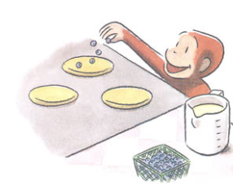

**Good/Service:** *Baker*

*Product*

**Capital Resources:**

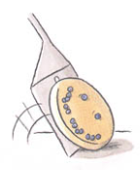 MC900340986[1]

*George’s Pancakes*

*Measuring Cups*

**Natural Resources:**

MCj03470650000%5b1%5d

*Eggs*

Activity Sheet-

~Productive Resources Web~

**Business**:

**Entrepreneur**:

**Human Resource:**

**Good/Service:**

*Product*

**Capital Resources:**

**Natural Resources:**