Why Did the Titanic Sink?
What Do You Think?
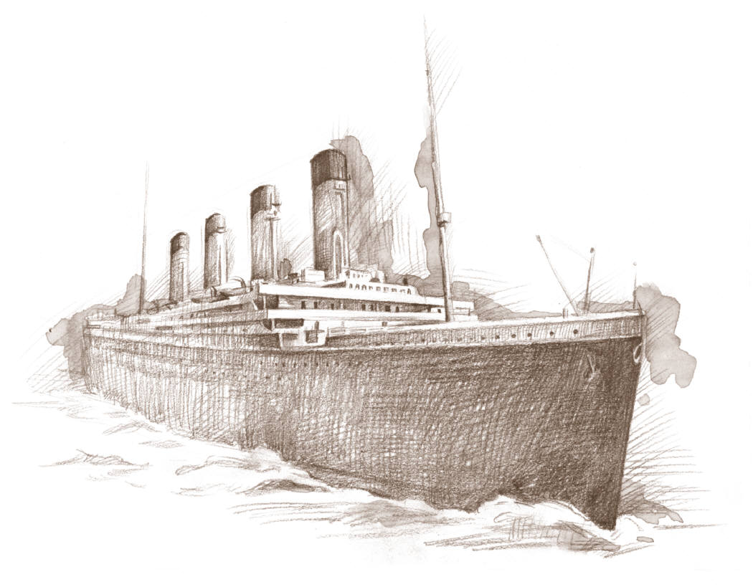

Introduction: The RMS Titanic was thought to be unsinkable. How could this have happened? Was one person responsible for this disaster, or was it a combination of series of unfortunate events?

Grade Level: 4-8

Time Required: 20-40 minutes

Materials:
- Visual- Why Did the Titanic Sink?
- Choice Cards (For Student Voting)

Concepts:
- Choice- A decision made between two or more possibilities or alternatives.
- Decision-making- Deciding among choices (alternatives or options).

Objective:
- The student will be introduced to possible causes for the Titanic disaster and choose one that they consider the most likely.

Procedure:
- Prepare the materials prior to class.
- Introduce the lesson by telling the students that 100 years ago the Titanic was considered a symbol of man’s advances in technology and was so well-constructed it could remain afloat no matter what the situation. However, on the morning of April 15, 1912, the Titanic sank and shocked the world. How this disaster came to be has been the topic of much study and debate.
- Display the visual, Why Did the Titanic Sink? Review its contents with the students.
- Place the four “What Do You Think?” cards at various places in the classroom.
- Tell the students that they must make a decision, based on the information they have learned, on who is most responsible for the sinking of the ship.
- Instruct the students to vote with their feet by getting out of their seats and standing near the card of their choice. Once they have voted they are to discuss their choice with the like-minded students in the group.
- Ask each group to tell the class why they made that specific choice.
- Inform any student who wished to change their choice to relocate. Tell the students that there is no right or wrong answer and historians have been debating this issue for decades.
- Conclude the lesson by posing the following questions for class discussion.
- Can you think of any evidence to suggest that money was a key factor in the Titanic disaster?
- How is the Titanic similar to the Costa Concordia which sank off the coast of Italy on January 13, 2012?

References for this lesson include:
- Encyclopedia Titanica http://www.encyclopedia-titanica.org/
- Titanic Eyewitness Books by Simon Adams. DK Publishing 2009.
- History on the Net http://historyonthenet.com/Titanic/titanicmain.htm

Why Did the Titanic Sink?
What Do You Think?

It was Captain Smith’s fault | It was the shipbuilder’s fault
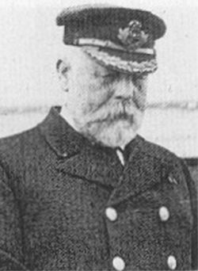  This was Captain E.J. Smith's retirement trip. All he had to do was get to New York in record time. Captain E.J. Smith said years before the Titanic's voyage, "I cannot imagine any condition which would cause a ship to founder. Modern shipbuilding has gone beyond that.”  Captain Smith ignored seven iceberg warnings from his crew and other ships. If he had called for the ship to slow down then maybe the Titanic disaster would not have happened. | 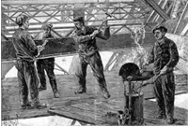  About three million rivets were used to hold the sections of the Titanic together. Some rivets have been recovered from the wreck and analysed. The findings show that they were made of sub-standard iron.  When the ship hit the iceberg, the force of the impact caused the heads of the rivets to break and the sections of the Titanic to come apart. If good quality iron rivets had been used the sections may have stayed together and the ship may not have sunk.
It was Bruce Ismay’s fault | It was Thomas Andrew’s fault
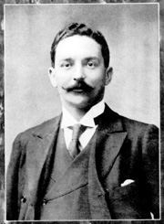  Bruce Ismay was the managing director of the White Star Line and he was aboard the Titanic. Competition for Atlantic passengers was fierce and the White Star Line wanted to show that they could make a six-day crossing.  To meet this schedule the Titanic could not afford to slow down. It is believed that Ismay put pressure on Captain Smith to maintain the speed of the ship. | 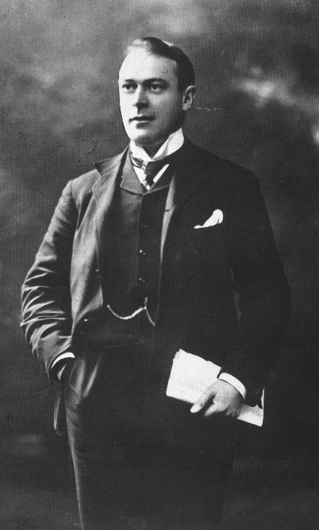  Thomas Andrews was the naval architect in charge of the plans for the Titanic. The belief that the ship was unsinkable was, in part, due to the fact that the Titanic had sixteen watertight compartments. However, the compartments did not reach as high as they should have done. The White Star Line did not want them to go all the way up because this would have reduced living space in first class. If Mr Andrews had insisted on making them the correct height then maybe the Titanic would not have sunk.

What Do You Think?
Vote With Your Feet Cards

It was Captain Smith’s Fault
(This was his last voyage before he retired.)

It was the Shipbuilder’s Fault
(Some rivets were made of sub-standard iron.)

It was Bruce Ismay’s Fault
(The “owner” of Titanic told Captain Smith to keep up the ship’s speed.)

It was Thomas Andrew’s Fault
(The Titanic’s designer chose the comfort of the first-class passengers over safety features)

