R-E-S-P-E-C-T Poems
Introduction: Challenge the students to use the poem pattern presented in RESPECT: Aretha Franklin, the Queen of Soul to create poems based on the meanings of economic concepts.
Poem Pattern
- First Line- Hyphenated vocabulary Word
- Second & Third Line- Couplet with lines ending with the long “e” sound
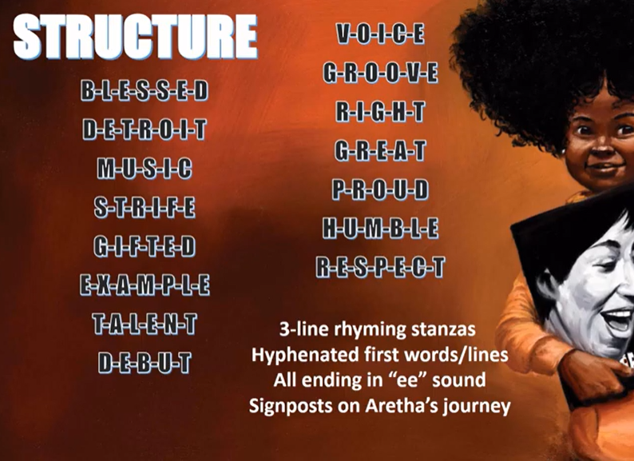
EXAMPLE FROM BOOK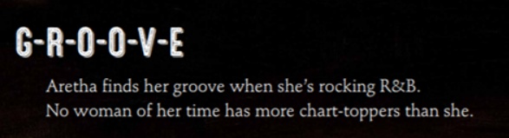
EXAMPLE FOR ACTIVITY
B-A-R-T-E-R
Exchanging goods and services without money
Is a method of trade that works for me.

Create Your Own “Groovy” Poem

Example:
O-P-P-O-R-T-U-N-I-T-Y C-O-S-T
When a decision is made, we soon see
What the next best choice given up will be

Suggested Economic Concepts & Terms

Capital Resource
Choice
Consumer
Credit
Decision
Demand
Earn

Entrepreneur
Goods
Human Resource
Money
Natural Resource
Opportunity Cost
Producer

Saving
Scarcity
Services
Specialization
Supply
Wage
Wants

Some Words with “ee” endings

Agree
Be
Carefree
Degree
Disagree
Fee
Free
Gee
Glee
Guarantee
ID
Key
Me
Money
Ph.D.
See
Shopping spree
Three
Tree
VIP
We

